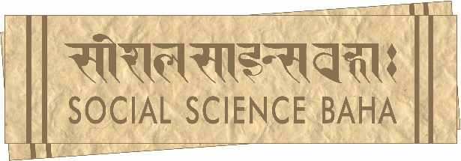
345 Ramchandra Marg, Battisputali, Kathmandu – 9, Nepal
Phone: 977-1-4572807⦁ www.soscbaha.org
Mailing address: GPO Box 25334, Kathmandu, Nepal

Application form

Social Science Baha seeks applications from qualified Nepali candidates for the following full-time position. Selection shall be based on merit and candidates from disadvantaged groups are encouraged to apply.

Position: Administrative Assistant
Number of positions: Two (2). Open only to Nepali citizens.
Educational qualification: Bachelor’s degree in Business Studies (BBS) or Business Administration (BBA) is required; and fluency in both spoken and written English
Application deadline: 31 October 2021 (Sunday)

Please read the following instructions carefully while applying.
1. Fill out the application form below.
2. Attach a covering letter, demonstrating your suitability for the position.

Please use the Tab function to navigate the form.

- Personal Information

Name:

Gender:

Date of Birth:
Permanent Address:

Current Residential Address:

Phone No: (home) (mobile)

E-mail:

The following response is meant only for administrative purposes and will not have a bearing on the selection process.

If you belong to a marginalised group, please indicate which one.

- Educational Background
Bachelor’s

Name of Institution:

Dates Attended:

Subjects:

Division/GPA:

High School

Name of Institution:

Dates Attended:

Division:

Have you obtained an educational degree higher than a BBS/BBA?

If yes, what is the highest degree you have attained?

- Language Skills
My overall command of English is:

Other language skills:

Language:

Language:

Language:

- Life Experience
Where have you travelled within and outside Nepal? For what reason(s)?

- Work Experience
Are you currently employed? Please specify the nature of your employment (part-time/full-time, place of employment, duration, responsibilities, etc.)

If you are not employed, what are you doing right now?

Have you worked in the past? Please provide details (place, duration, responsibilities, etc.) In what field do you seek a career?

Please give names of two referees who know you well and who may provide us with information about you. Provide contact details including phone numbers where possible.

I hereby declare that the information in this application provided is true and correct. I also understand that any wilful mischaracterisation or dishonesty may lead to this application being refused or immediate termination of employment in the future.

Should my application be successful, I hereby authorise Social Science Baha to keep this information in my personal file. Otherwise, all information will be destroyed within six months after the date of application.

Signed with initials

Date:

Please email the complete application package to info@soscbaha.org by 31 October 2021 (Sunday).

