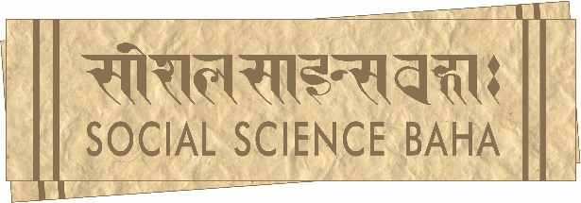
345 Ramchandra Marg, Battisputali, Kathmandu - 9, Nepal
Phone: 977-1-4572807⦁ www.soscbaha.org
Mailing address: GPO Box 25334, Kathmandu, Nepal

Application form
Social Science Baha is looking for Researchers to work on a broad array of topics, including labour and migration. Selection shall be based on merit and candidates from disadvantaged groups are encouraged to apply.

Please read the following instructions carefully while applying.
1. Fill out the application form below.
2. Attach a covering letter, indicating your suitability for the position.
3. Include your curriculum vitae not exceeding two pages to the application package.

Please use the Tab function to navigate the form.

- Personal Information
Name:

Sex:

Date of Birth:
Permanent Address:

Current Residential Address:

Phone No: (home) (mobile)

E-mail:

The following question is meant only for administrative purposes and will not have a bearing on the selection process.

If you belong to a marginalised group, please indicate which one.

- Educational Background
Master’s

Name of Institution:

Dates Attended:

Subjects:

Division/GPA:

Bachelor’s

Name of Institution:

Dates Attended:

Subjects:
Division/GPA:

High School

Name of Institution:

Dates Attended:

Division:

- Language Skills
My overall command of English is:

Other language skills:

Language:

Language:

Language:

- Life Experience
Where have you travelled within and outside Nepal? For what reason(s)?

- Work Experience
Are you currently employed? Please specify the nature of your employment (part-time/full-time, place of employment, duration, responsibilities, etc.)

If you are not employed, what are you doing right now?

Have you worked in the past? Please provide details (place, duration, responsibilities, etc.) In what field do you seek a career?

Please give names of two referees who know you well and who may provide us with information about you. Provide contact details including phone numbers where possible.

Date:

Please email the complete application package to info@soscbaha.org by 13 August 2021 (Friday).

